Divine Praises
After the blessing of the congregation, the priest kneels at the foot of the altar and leads the recitation of the Divine Praises.
Blessed be God.
Blessed be His Holy Name.
Blessed be Jesus Christ, true God and true Man. Blessed be the Name of Jesus.
Blessed be His Most Sacred Heart. Blessed be His Most Precious Blood.
Blessed be Jesus in the Most Holy Sacrament of the Altar. Blessed be the Holy Ghost, the Paraclete.
Blessed be the great Mother of God, Mary most Holy. Blessed be her Holy and Immaculate Conception.
Blessed be her Glorious Assumption.
Blessed be the name of Mary, Virgin and Mother. Blessed be St. Joseph, her most chaste spouse. Blessed be God in His Angels and in His Saints.

CLOSING HYMN: Holy God, We Praise Thy Name

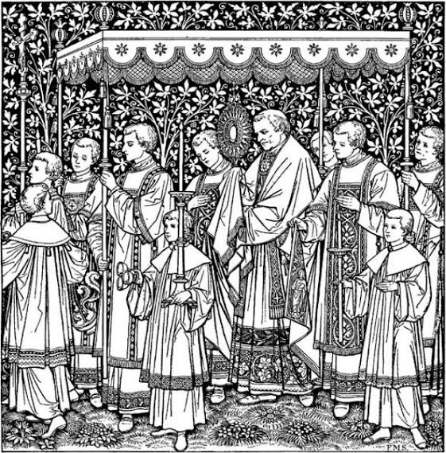
Holy God, we praise Thy Name; Lord of all, we bow before Thee! All on earth Thy scepter claim, All in heaven above adore Thee; Infinite Thy vast domain, Everlasting is Thy reign.

Hark! the loud celestial hymn Angel choirs above are raising, Cherubim and seraphim,
In unceasing chorus praising;
Fill the heavens with sweet accord: Holy, holy, holy, Lord.

Holy Father, Holy Son,
Holy Spirit, Three we name Thee; While in essence only One, Undivided God we claim Thee; And adoring bend the knee, While we own the mystery.

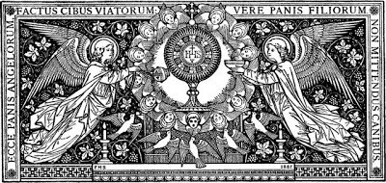

Holy Hour
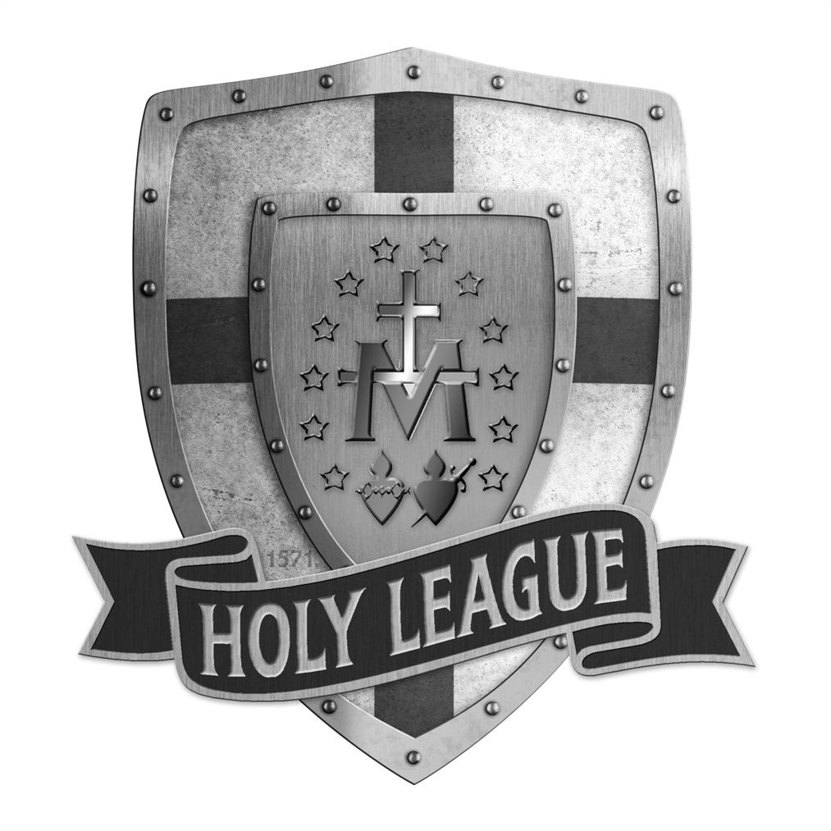
Adoration & Benediction

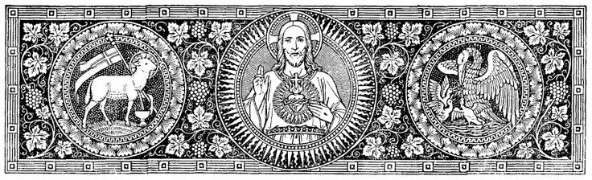
EXPOSITION
BENEDICTION
OF THE BLESSED SACRAMENT
The Benediction of the Blessed Sacrament is a rite in which Jesus, in the Sacrament of His love, is not only exposed to the adoration of the faithful, but in which He, present in that Sacrament, is implored to bless the faithful present before the Altar. It is not the priest who blesses the people in this rite, it is Jesus Christ Himself, in the Blessed Sacrament, Who bestows His benediction upon them.

OF THE BLESSED SACRAMENT
When the priest opens the tabernacle and incenses the Blessed Sacrament, the hymn O Salutaris Hostia is sung:
Tantum ergo Sacraméntum Venerémur cérnui:
Et antiquum documéntum Novo cedat ritui:
Praestet fides suppleméntum
Down in adoration falling, Lo! The Sacred Host we hail!
Lo! o’er ancient forms departing, Newer rites of grace prevail.
Faith for all defects supplying

O salutáris hôstia,
Quae caeli pandis óstium, Bella premunt hostilia, Da robur, fer auxilum.

Uni Trinóque Domino, Sit sempitérna gloria: Qui vitam sine término, Nobis donet in pátria.
O Saving Victim! Opening wide The gate of Heaven to man below! Our foes press on from every side; Thine aide supply,
Thy strength bestow.

To Thy great Name be endless praise,
Immortal Godhead! One in three!
Sénsuum deféctui.

Genitori, Genitoque Laus et jubilatio,
Salus, honor, virtus quoque Sit et benedictio:
Procedenti ab utroque Compar sit laudatio. Amen.
Where the feeble senses fail.

To the everlasting Father,
And the Son Who reigns on high With the Holy Spirit proceeding Forth from each eternally,
Be salvation, honor blessing, Might and endless majesty. Amen.

Amen.
O grant us endless length of days,
In our true native land with Thee! Amen.

ADORATION & CONFESSION
V: You have given them bread from heaven.
R: Having within it all sweetness.
Priest/Deacon:
Let us pray. Lord Jesus Christ, You gave us the Eucharist as the memorial of Your suffering and death. May our worship of this sacrament of Your Body and Blood help us to experience the salvation You won for us and the peace of the kingdom where You

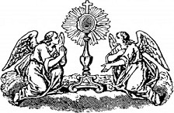
To encourage a prayerful spirit, a brief reflection by the priest or deacon is encouraged. The Catholic Church has its own rhythm, and each month has a special devotional emphasis. Reflecting on each of these is encouraged for each month’s Holy Hour. After this brief reflection, it is recommended to play a CD of Gregorian Chant (softly) to assist adorers in a sense of the sacred. Also, to assist adorers in their prayer, there are many beautiful prayers and prayer methods available in the Holy League Prayer Book (A bible, breviary or other prayer books are also laudable). The priest(s) then makes himself available for confession for the remainder of the adoration time.
live with the Father and the Holy Spirit, one God, for ever and ever.
All respond: Amen.

Eucharistic Blessing
After the prayer, the priest or deacon puts on the humeral veil, genuflects, and takes the monstrance or ciborium. He makes the sign of the cross over the people with the monstrance or ciborium. Meanwhile, an acolyte rings the bell, and all bow in adoration as Benediction is given with the Blessed Sacrament.

Reposition
After the blessing the priest or deacon who gave the blessing reposes the Blessed Sacrament in the tabernacle and genuflects.

